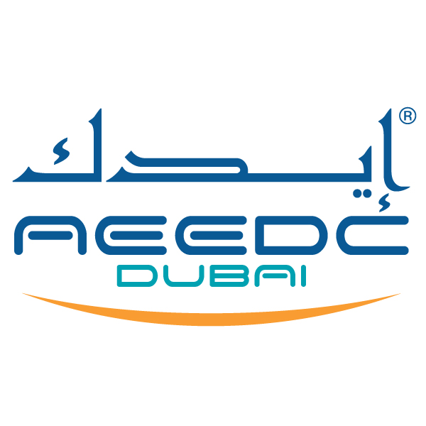
UAE International Dental Conference & Arab Dental Exhibition
AEEDC Dubai 2019
5th – 7th February

Dubai International Convention and Exhibition Centre

AEEDC Young Researcher Award

Application Form

Deadline: 1st of December 2018
For office use only

Date Rcvd. ______________________

Reg. No. ________________________

Abs. No. ________________________

Please complete and submit this form to:
INDEX Conferences & Exhibitions Organisation Est.
P.O. Box: 13636, Dubai – United Arab Emirates
Tel: +97145208888, Fax: +97143384193
E-mail: abstract@aeedc.com; aeedc@index.ae

Researcher Name:

Researcher Age:
Title: | Prof. Dr. Other, please specify
Presentation Category: | Aesthetics  Anaesthesia  Dental Emergency  Dental Ergonomics  Dental Ethics  Dental Hygiene  Dental Laboratory Technology  Dental Practice Growth (Management, Marketing, and IT integration)  Endodontics  Four Handed Dentistry  Infection Control  Laser Dentistry  Oral and Maxillofacial Surgery  Oral Implantology  Oral Pathology, Oral Medicine  Orthodontics  Pediatric Dentistry  Periodontology  Prosthodontics  Restorative Dentistry  Robotic Dentistry  Other ,please specify----------------------------------------
Sector: | UAE GCC & MENA region International  Academic Private Other, please specify
Researcher’s
Profile:

(Maximum of 50 words)

Degree:
( e.g. :MSc. FDS RCS, PhD, FHEA )

Current Position:

CV: | Kindly attached your full CV.
Photo: | Kindly attached your Current photo: (High resolution)  Format: JPG or pdf  Resolution: 300 dpi  File size: more than 1 mb
Research Title:

(Maximum 20 words)
Abstract: (Maximum of 100 words)

Introduction: (Maximum of 200 words)

Materials & Methods: (Maximum of 50 words)

Results: (Maximum of 50 words)

Conclusion: (Maximum of 50 words)

Note:  Previously published or will be published? | Yes or No
Contact Information
Organisation:
Tel:
Mob:
Fax:
Email:
Address:
Abstracts not complying with the specified format will not be considered.

AEEDC Young Researcher Award application prerequisites:

- The candidate should be 40 years of age or below.
- The research must be already concluded, and with no pending parts, within 2 years before the date of the award.
- The research should already be recognized by the research/thesis committee/department of a University.
- The research should be either already published, or be scheduled for publication in a peer review journal.
- The research should be original and unique of its kind.
- The research should add both theoretical scientific value and real time clinical value to one or more of the fields related to dentistry.
- The application must be completed by 1st of December 2018.
- The outline of the research should be presented within this form.

Abstract Submission Guidelines:
*(The term organiser means INDEX Conferences & Exhibitions Organisation Est.)
- Abstract should not exceed 100 words. The abstract must be in English, font size 12 in Times New Roman font and with single-line spacing.
- Application should be submitted by e-mail. Abstracts that are handwritten, or sent by fax will not be accepted.
- Abstract content must meet the standard of an academic / scientific presentation. The outline must have an Introduction, Objectives, Materials and Methods, Results and Conclusions.
- The abstract must be based on original research or original clinical case studies.
- The Awards’ Committee will evaluate the content of each abstract and make the final selection.
- No abstracts will be considered after 1st of November 2018.
- For any withdrawals, the researcher should notify the *organiser in writing at least 1 month prior to the event.

Disclaimer Statement

In order to maintain efficiency, the following disclaimer should be signed and understood, illuminating the Speaker/Author and Organizer/Event responsibilities.

I understand that the submission of a research does not automatically enrol me as a candidate to AEEDC Young Researcher Award.

Being an applicant to AEEDC Young Researcher Award speaker/author in AEEDC Dubai 2018, I undertake to complete and submit any other disclosure statements required by any other organization, including the conference organizer, in relation to my participation in AEEDC Young Researcher Award, and I guarantee that the disclosure statement will be complete and truthful to the best of my knowledge.

I have made every effort to guarantee the accuracy of the information supplied herein in the abstract form, and hereby disclaim all warranties with regards to the information included on this form without limitation.

I understand that if my research is accepted for presentation in AEEDC Young Researcher Award, the organizer has the right to publish it in Dental Horizons.

I fully understand that AEEDC Dubai will not be held responsible for any errors or omissions in the information present in this form and /or in my research.
- I understand that I will be solely responsible for my research, and that AEEDC Dubai takes no responsibility, and disclaims any liability, for any information and conclusions.
- I understand that a brief abstract /information about my research will be published and/or posted online within all AEEDC Dubai and AEEDC Dubai related websites, to public.

By signing this statement, I declare that the mentioned terms and conditions in points (1) to point (7) in the disclaimer statement and the guidelines for abstract submission and presentation are understood and accepted, and will be complied with and maintained.

Signature: Date of application:

