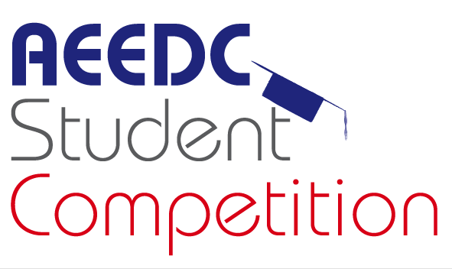
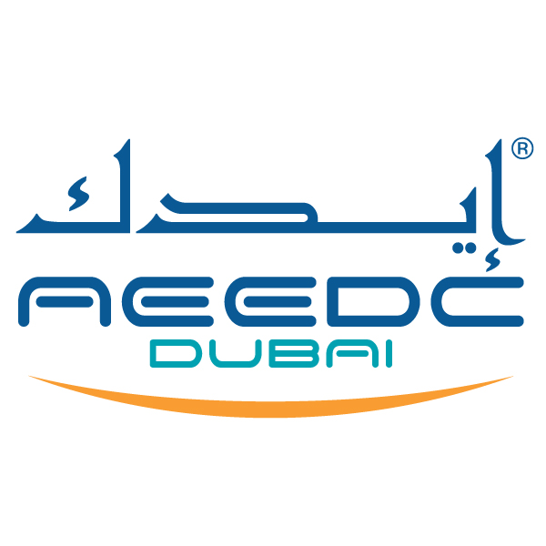
UAE International Dental Conference & Arab Dental Exhibition
AEEDC Dubai 2019
5th – 7th February

Dubai International Convention and Exhibition Centre

AEEDC Students Competition
Participation Form
For office use only

Date Rcvd. ______________________

Reg. No. ________________________

Abs. No. ________________________

Please complete and submit this form to:
INDEX Conferences & Exhibitions Organisation Est.
P.O. Box: 13636, Dubai – United Arab Emirates
Tel: +97145208888, Fax: +97143384193
E-mail: jeanette.sales@index.ae ; rania.alharidi@index.ae

University Name:

Dental Faculty Dean Name:
Contact Person Name:

Team Supervisor Name:

Team Members Names:

Official Confirmation letter: | Please attach the official confirmation letter signed by the dean
University Logo: | Please attach university logo:(High resolution)  Format: EPS, Illustrator  Resolution:300dpi
Contact Information
Tel:
Mob:
Fax:
Email:
Address:

General Guidelines and Regulations:

- No participation forms will be considered after 20th November 2018.

Submission of the participation form does not automatically entitle the applicant to participate in AEEDC Students Competition 2019.
- Incomplete participation form will not be accepted as all required information should be received before the submission deadline.
- For any withdrawals, the participants should notify the *organiser in writing as soon as possible or minimum of 2 months prior to the event.
- Academic team is made up of (5) students which will be nominated from each university to be part of the competition.
- Participants must be bonafide students from the representing dental college.
- Participants must be in clinical practice stage (fourth or fifth academic year)
- Each team is supervised by one faculty member from the same university.
- The faculty member supervisor will nominate one team leader (captain) from the five students to be the representative of the team while answering the questions.
- All the team members and their supervisors must be registered in the conference.
- A draw process will select the competing teams in the preliminary round and will be announced in the AEEDC Student Competition webpage one week prior to the event.
- The student competition teams with the higher scoring points in the elimination round(s) will be qualified for the final round.
- The winner team will be decided according to the competition mechanism.

For more information please refer to the “competition mechanism”:
http://aeedc.com/scientific-activities/aeedc-student-competition/

By signing this statement, I declare that the mentioned General Guidelines and Regulations in points (1) to point (13) are understood and accepted, and will be complied with and maintained.
Signature: Date:

